# Scots Bay Survey #1 Sunday May 5, 2024

This survey will include 3 participating vessels.

Vessels will complete the following lines: The Lady Melissa will do two lines in the main box and two in the Eastern Box. The Brunswick Provider will complete three lines within the main box. Morning Star will do one line in the main box line (south of Isle Haute) and then complete the Northern box.

The survey will have a start time of 20:00.

The Lady Melissa will conduct plankton tows and oceanographic sampling prior to the survey starting.

Vessels are reminded to complete their assigned transects as listed, straight, and without deviating.

**When running your transect, if you are recording a school of fish but are near the end of your line, please continue recording in a straight line even if it extends beyond the boundaries of the survey box.**

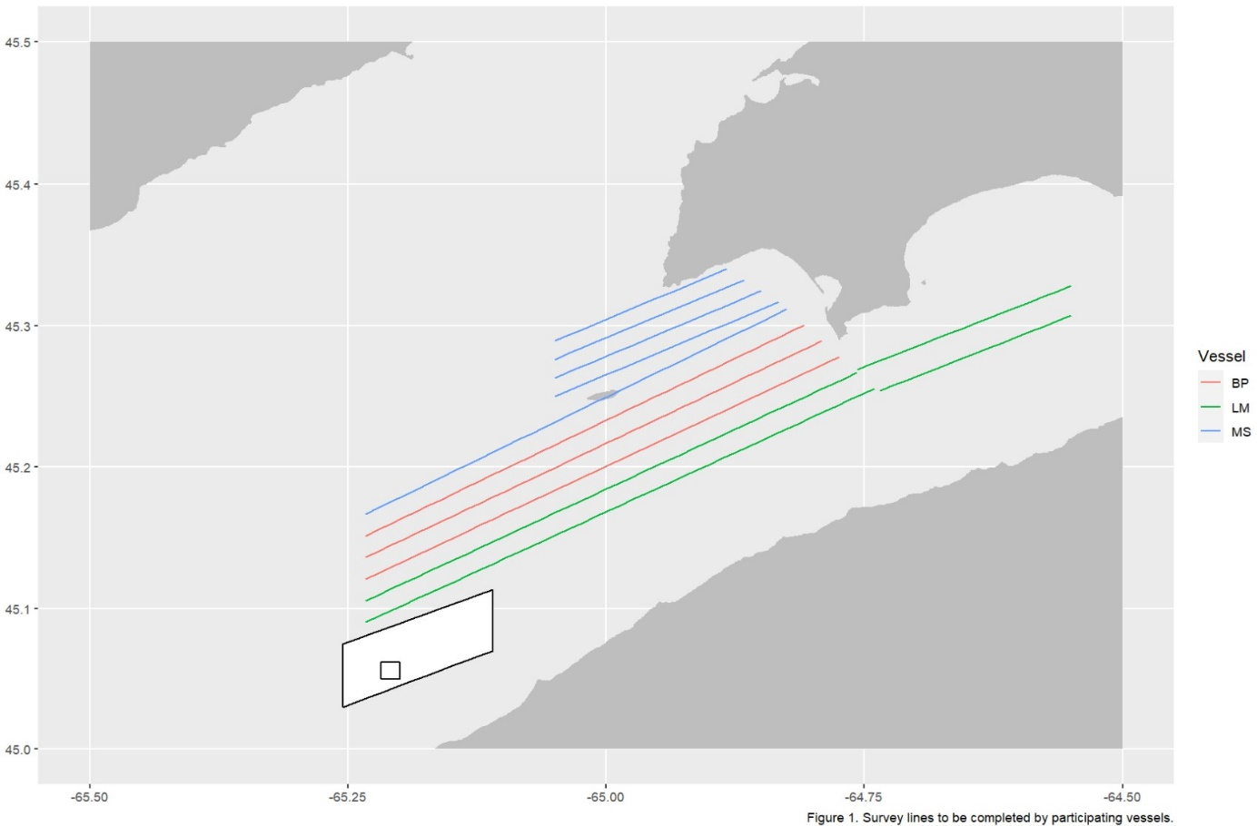

The Lady Melissa will complete plankton tows (bottom left outer box) and CTD cast (bottom left inner box).

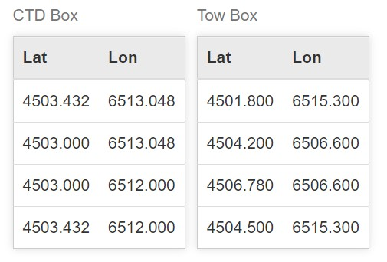

Full Lines Table

|  |  |  |  |  |  |
| --- | --- | --- | --- | --- | --- |
| Vessel | Line No. | Start Lat | Start Lon | End Lat | End Lon |
| Lady Melissa | 1 | 4505.401 | 6514 | 4515.331 | 6444.42 |
| Lady Melissa | 2 | 4515.238 | 6444.113 | 4518.408 | 6433 |
| Lady Melissa | 3 | 4519.7 | 6433 | 4516.12 | 6445.43 |
| Lady Melissa | 4 | 4516.005 | 6445.436 | 4506.321 | 6514 |
| Brunswick Provider | 1 | 4507.241 | 6514 | 4516.679 | 6446.452 |
| Brunswick Provider | 2 | 4517.352 | 6447.468 | 4508.16 | 6514 |
| Brunswick Provider | 3 | 4509.08 | 6514 | 4518.026 | 6448.484 |
| Morning Star | 1 | 4510 | 6514 | 4518.7 | 6449.5 |
| Morning Star | 2 | 4519 | 6450 | 4515 | 6503 |
| Morning Star | 3 | 4515.783 | 6503 | 4519.467 | 6451 |
| Morning Star | 4 | 4519.933 | 6452 | 4516.567 | 6503 |
| Morning Star | 5 | 4517.35 | 6503 | 4520.4 | 6453 |

Instructions

1. Plan to arrive at the starting point 30 minutes before the start time of 20:00.
2. Start the EK80 software and load your 2024 Herring Survey settings. When you are ready to begin, Record Raw should be turned ‘ON’ and the ‘REC’ dot in the upper left should turn from black to red. Check that the lat and long in the top center of the screen is changing.
3. Commence surveying first line at 20:00 and maintain a speed at 8 knots.
4. Run your lines straight and double check that the recorder is turned on and red.
5. Maintain log sheets as a backup to recorders every 15 minutes.
6. Note the time when finished your last line.
7. This is a non-fishing survey.

Tidal Charts

